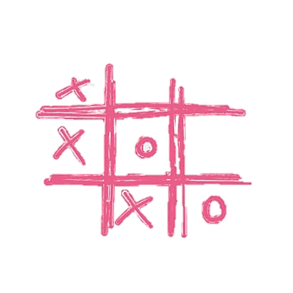Piece of mind game proposal

## Background and motivation.

The tic tac toe game is believed to date back to the early Roman empire where it was originally called terni lapilli or otherwise known as three pebbles. It was later adopted in the 1800s in the British Empire where it was referred to as noughts and crosses. In the original game there was no markings on paper or its equivalent but was rather played where each player had 3 pebbles and would move it around in a circle with 9 lines. 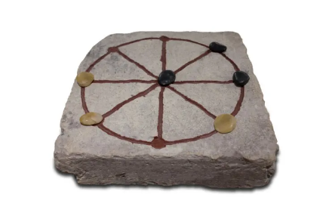

The motivation behind this game is just to rest the mind and allow for people to play games in a busy world. The group name is a play on words which speaks on the motivation as it is a piece of the mind being used to gain peace of mind.

The game will be multiplayer and single player oriented and will make it so there is score keeping as well.

## Problem statement.

The issue with this game may lay with the single player aspect as it may be needed to either create a randomised method to allow the CPU to play as well or it might have to contain an AI which is out of my coding capabilities and would require for me to implement code that is not mine. Additionally, it might be a problem to code in android studio as it as an app that I have never seen, heard of or used before. Lastly, being a solo team might prove to be more work than I can do alone.

## Approach.

The approach I intend to take for this game is a java-based approach that will look into firstly creating the different classes for the single player or the multiplayer aspect this will include all the decision on whether or not I will implement a randomised CPU response or implement referenced coding. Because of the nature and simplicity of the game the GUI will subsequently be simple and user-friendly from launch.

## Timeline.

|  |  |  |
| --- | --- | --- |
| **Objective** | **Begin** | **End** |
| Proposal and Git hub read me | 27 September | 30 september |
| Code planning | 1 October | 3 October |
| Actual coding | 3 October | 5 October |
| Design and documentation | 5 October | 6 October |

References

<https://pngtree.com/so/tic-tac-toe> [Accessed: 27 September, 2023]

*The history of tic tac toe and where it is now* (2021) *Aurosi*. Available at: https://aurosi.com/blog/the-history-of-tic-tac-toe-and-where-it-is-now/ (Accessed: 27 September 2023).

Team, G. (2022) *Tic-tac-toe (Noughts & Crosses): Origins, history, evolution,...*, *Gamesver*. Available at: https://www.gamesver.com/tic-tac-toe-noughts-crosses-origins-history-evolution/ (Accessed: 27 September 2023).

Wonders, T. (no date) *How old is tic-tac-toe?*, *Wonderopolis*. Available at: https://wonderopolis.org/wonder/how-old-is-tic-tac-toe (Accessed: 27 September 2023).